**Athlone Institute of Technology**



**Project Thesis – Academic Year 2019/20**

**Beat Saber**

**By**

**Varun Kumar Tiwari**

**A00268806**

**Bachelor of Engineering (Honours) in Software Engineering**

**Beat Saber**

(Involvement of machine learning in-game)

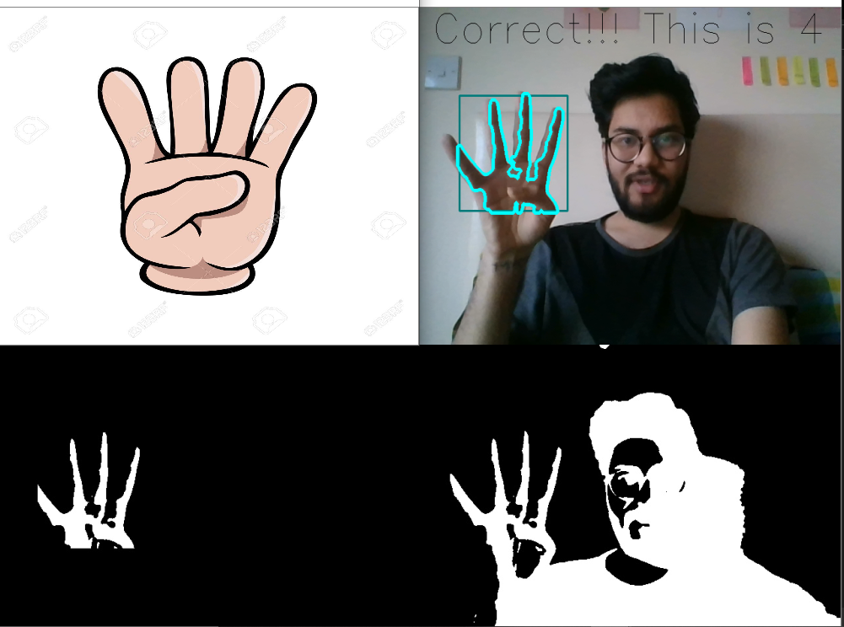

**Author: Varun Kumar Tiwari**

**Supervisor: James Byrne**

# Project Summary

This report follows the building of Beat Saber (ML Game). Beat Saber is a demonstration to test the technology of Machine learning. As machines are getting intelligent and can recognize multiple things such as temperature in a room to switch off the heater (automation). While keeping this in mind machine learning can be applied in games also. This will explore the capabilities of latest trend in market ‘Machine Learning’ and building of ML based software solution. The report will set out how and where the idea came from, and how it was developed and designed. This report will outline how working of this project achieved and what kind of problem appeared with the working solution.

Table of Contents

Project Summary 3

Introduction 5

Aims and Objectives 6

Objectives 6

Scope 6

Build Tools 7

(Hardware & Software) 7

Minimum Hardware Requirement 7

Software Requirement 7

Research Introduction 9

1. VR Beat Saber [1] 9

2. My Application 10

3. Hand Recognition [7] 11

How it Works 12

Application Research 13

Design 14

Implementation 17

Methodology 17

Environment Setup 17

Testing 28

Evaluation 41

Conclusion 42

References 43

# Introduction

The purpose of this report is to show the implementation of a game built in machine learning. This report aims and explore the implication of ML in game. Idea of this project came from a popular game know as Beast saber [1] which is a virtual reality rhythm game which requires virtual reality headsetfor example PlayStation VR, HTC Vive and Oculus Rift. This game takes place in surrealistic neon noir environment. A player has VR set and slicing blocks representing musical beats with a pair of contrasting coloured sabers. This project does not require any of the gageites just a webcam and a laptop or pc.

The project is a combination of 4 things, first recognition of hand through webcam, second changing of picture, synergizing of hand recognition with the shown picture and lastly calculate the score.

To start designing the application, I first learned about the hand recognition because it was the most difficult part of the project. I have come to know many new things like Thresholding, Contour and Convex hull. Then the second most difficult thing in the project was to synergize the hand recognition output to the picture. After that I have connected all the bits and pieces.

# Aims and Objectives

This report will describe the development of the ML [2] base Beat saber game. Beat Saber is a demonstration where users can play. The user must sit in front of the camera and randomly generated hand shape will appear on a screen. By the help of hands, user can make that shape and the number of time user make the hand sing score will get added. The recognition of the hand is done by a script return in python. At the end of 1-minute score will appear based on how many sings user made.

# The aim of developing this project is to make Games in an efficient form of learning as it enables students to simulate events in real life. Most games in the field of project management concentrate on the project planning process. My idea is about presenting a new game. The beauty of this game is its emphasis during execution of the project on real world problems.

# Objectives

1. The main idea behind this project is to deal with a low-quality laptop camera and still manage to capture the movements of hand without using any other external tool.
2. Detect hand through camera.
3. To learn how to extract hand and count the number of fingers.
4. Learn how to program in Spyder [3].
5. Learn about OpenCV [4].
6. Set up environment for the project.

# Scope

The scope of the project is to just use machine learning in a simple game and to get familiar with machine learning and artificial intelligence. This project aims to build a system to use machine learning with very less and low-quality devices. So, it can prove that user can play game with the very basic requirement and still get high accuracy.

Build Tools

(Hardware & Software)

Beat Saber is a game built with the very basic requirement and aiming to get high accuracy. Since this whole project is dependent on the machine learning, it will require a strong processor and few of the software which are easily available on the internet.

Minimum Hardware Requirement

Beat Saber does not require special equipment except for a personal computer (PC) and a webcam. The CPU should have at least two cores to handle the enormous amount of calculations needed for the image processing unit.

* Webcam or external camera.
* Processor: Intel Pentium IV Processor
* RAM: 2 GB
* Hard Disk: 10 GB
* Monitor

Software Requirement

* **Python 3** [5]

Python is a high-level, object-oriented, interpreted programming language with dynamic seance. Connecting existing components together is highly utilized for scripting or glue language. Python is quick, easy to learn syntax that underlines readability and therefore reduces software maintenance costs. Python supports modules and packages which promote modularity of the program and reuse of code. The Python interpreter and the comprehensive standard library are accessible for all major platforms without charge in source or binary format and can be distributed freely.

* **Anaconda** [6]

Anaconda is a free and open-source allocation of the Python and R programming languages for technical computing (data science, machine learning application, large-scale data processing, predictive analysis) aimed at simplifying package management and deployment. Package variants are managed via the conda kit management system. The Anaconda distribution provides software for Windows, Linux, and macOS suitable for data-sciences. [2]

* **Spyder** [3]

Spyder is an opensource cross-platform integrated development [environment](https://en.wikipedia.org/wiki/Integrated_development_environment) (IDE) for scientific programming in the Python [5]Language. Spyder integrates with a number of prominent packages in the scientific Python stack, including NumPy, SciPy, Matplotlib, pandas, JPython, SymPy and Cython as well as other open source. [3]

* **OpenCV** [4]

OpenCV is an open source computer vision and software library for machine learning. OpenCV was designed to provide a shared computer vision platform and to promote the use of machine perception in commercial products. OpenCV makes use and alteration of the code simple for companies. The library has more than 2500 developed algorithms, which include a detailed collection of computer vision and machine learning algorithms, both classic and state-of-the-art. These algorithms can be used to detect and recognize faces, recognize objects, classify human behavior in images, monitor camera movements, monitor objects moving and much more.[4]

# Research Introduction

Beat Saber game is a combination of hand gesture recognition and image processing. In today’s world these areas are very active in computer vision field. It makes it easy to communicate with machines without using any extra tool even if users don't have a lot of technical knowledge about the system, they can still use the system using their regular hands. This paper is the extended version of simple hand gesture recognition, as this project uses the recognition to calculate the number of gestures made by the user showed in the image box.

# VR Beat Saber [1]

The main Idea behind the project was to make the game like VR Beat Saber. VR games are the interactions simulated that could be close to or entirely different from the actual world. Virtual reality systems currently use either virtual reality headsets or multi-projected atmospheres to produce realistic images, sounds, and other sensations that simulate the physical presence of a user in a virtual setting A person using the equipment for virtual reality can look around the artificial world, move around in there and communicate with virtual features or items. The effect is generally created by VR headsets made up of a head-mounted display with a tiny screen in front of the eyes, and it can also be formed with multiple large screens through specially designed rooms.

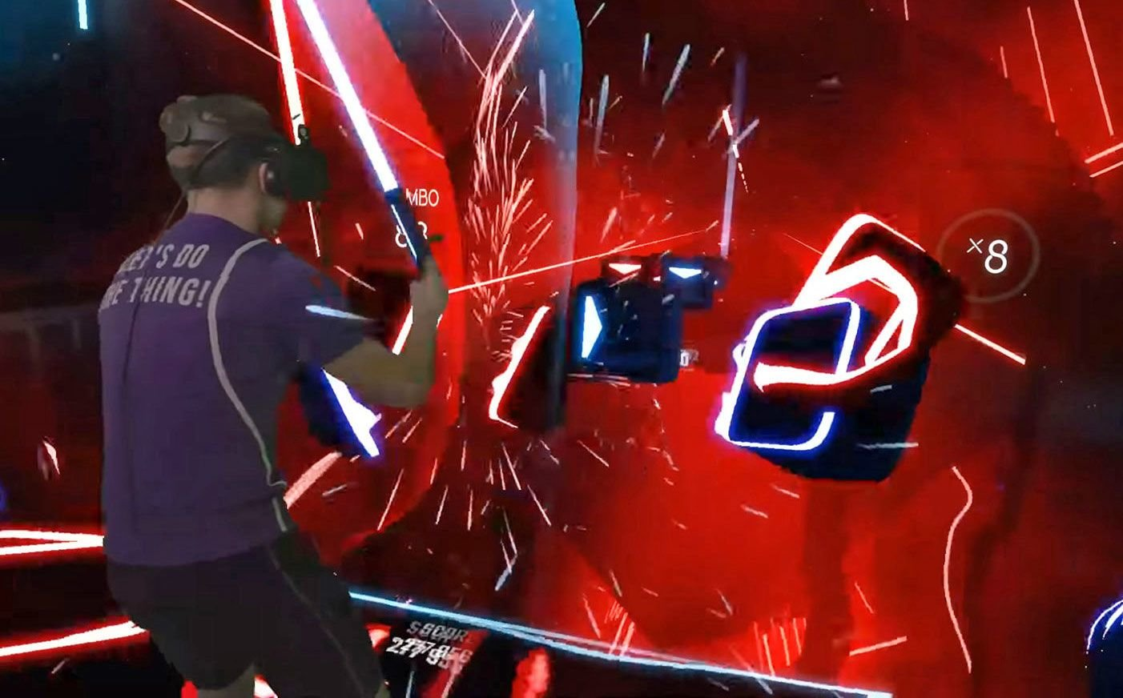

# My Application

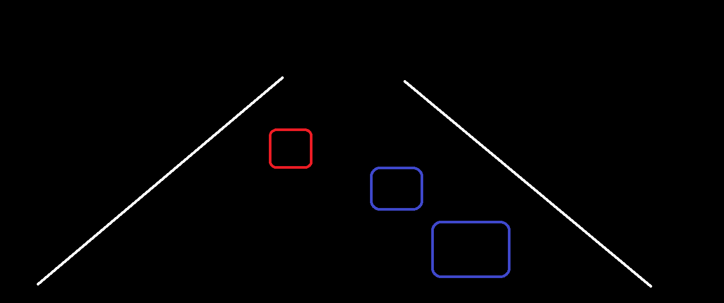The project meant to be similar to the original VR Beat Saber but to create the real cool and feel it will require specially designed rooms with multiple large screens but that is not feasible because our aim of the project is different. For the initial image of the project, I thought of recognition the whole body and the finial product might look like this.

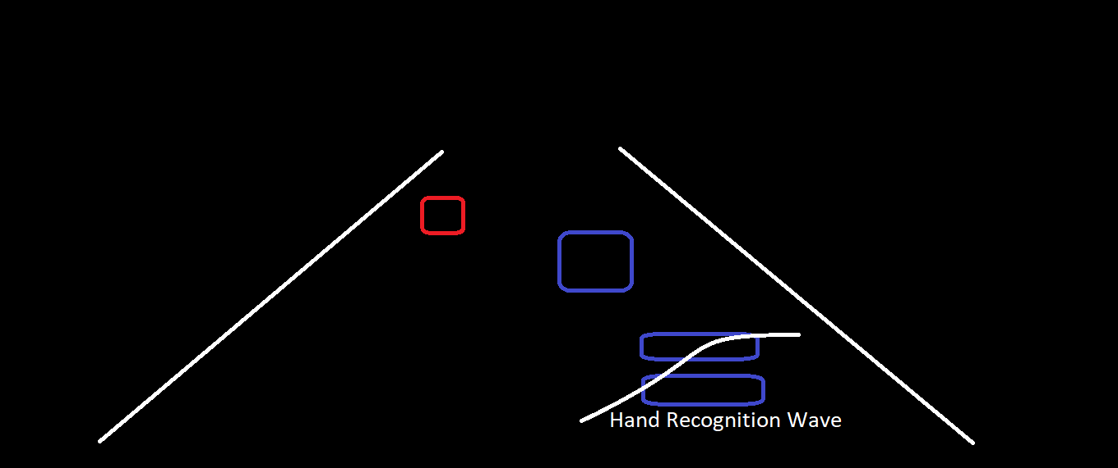

Only after few weeks I come to know that reorganization that whole body cannot be done with the requirements mention above. That keeping in mind I move to hand recognition which is also a good idea. Then I have started to study hand recognition.

# Hand Recognition [7]

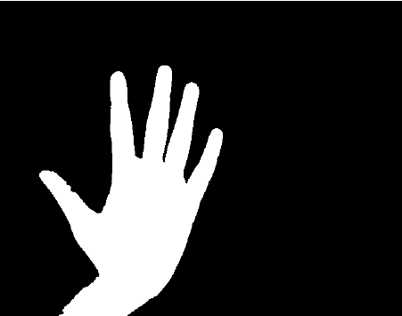A histogram-based approach is used to separate out a hand from the background image. Background cancellation techniques are used to obtain optimum results. The detected hand is then processed and modelled by finding contours and convex hull to recognize finger and palm positions and dimensions. Finally, a gesture object is created from the recognized pattern which is compared to a defined gesture dictionary.

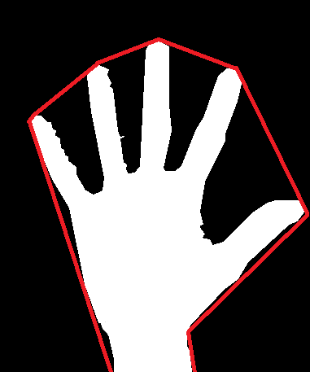 Fig. Contour

Fig. Convex hull

# How it Works

e overview of the hand

gesture recognition is described in Figure .First,thehandis

detected using the background subtraction method and the

result of hand detection is transformed to a binary image.

en, the ngers and palm are segmented so as to facilitate

e overview of the hand

gesture recognition is described in Figure .First,thehandis

detected using the background subtraction method and the

result of hand detection is transformed to a binary image.

en, the ngers and palm are segmented so as to facilitate

First, the hand is identified using the subtraction method of the background and the manual detection result is transformed into a binary image. Then, the fingers and palm are divided to allow identification of the finger. In addition, it tracks and recognizes the digits. Using a simple classifier, the hand motions are recognized last.

e overview of the hand

gesture recognition is described in Figure .First,thehandis

detected using the background subtraction method and the

result of hand detection is transformed to a binary image.

en, the ngers and palm are segmented so as to facilitate

# Application Research

# Hand Gesture Recognition is a well learned subject in the Machine Learning [2] community, Computer Graphics and Image Processing industry. Recognition-based program follows mathematically rich and complicated algorithms whose main aim is to teach a particular gesture to a computer. Since there are very broad sets of gestures, there's also a large range of methodologies to define the set of gestures. In this study I concentrated on the hand-based gestures. The thesis is divided into two parts, namely: Dynamic and Static mode. The Static mode is focused on movements based on still images and Dynamic mode is focused on movements based on image series.

Since the dawn of humanity, gestures have a part of our life. One can convey many emotions through just one gesture. A wide variety of group are conducting the study of gesture recognition. But the field of gesture recognition mostly belongs to the Computer Science department. The main objective of gesture recognition is to educate a computer to learn and communicate with different gestures made by humans and to do the same. The probable position for a gesture's origin may be from any part of our body, but most of the gesture research studies involve the gesture that originated from the hand or the face. The explanation for transmitting the message through the hand gestures or facial expressions is that most regular people do. The abundance of dataset available for different facial expression of postures and hand movement, draws a lot of researchers to do their work in this area. The whole point of Gesture recognition systems is to make it possible to have a sensible conversation between a person and a computer. We humans as a species have always wanted to make our lives as easy as possible and history is evidence that the invention of the computer has contributed to improved living standards. Recognition of hand movement can be used in home appliances, professional photography, robot control, etc.

# Design

Path of Static mode of Hand Gesture Recognition

Hand

Segmentation

Feature

Extraction

Feature

Selection

Classification

Vote # 0

Candidate id

Voter Account

Amount

Hash

authenticates

Flow Chart of the System

Initialize Video Capture

Grab frame

Remove background

Crop Hand Image

Convert to Binary

Resize to 64x64 pixels

Extract features

Classify gesture

**Data Flow Diagram**

Camera

User

Driver

Background detection

& removal

Frame Extraction

Color detection

Application

Vector calculation

Gesture

Database

Pattern matching

Thresholding

RGB to HSV

OS interface

Applying Gaussian Blur

# Implementation

## Methodology

This project requires following step to execute

1. Changing the image automatically every 6 second.
2. Recognizing the hand gesture through Haar cascade [8].
3. Taking the output as number to fingers and sync with automatically change image.
4. Update the score.

## Environment Setup

From writing the script till the execution of the project, it needs to have few software and that also includes the environment setup.

Dependency

1. Python 3.7 [5]
2. Anaconda [6]
3. Spyder [3]
4. OpenCV [4]
5. Hand Haar cascade

**Python 3.7**

Python [5] 3.7 is the latest Python version available on the Internet and if we run the program on the previous version of Python it might show some syntax error and project what's fine in the later version of Python like 8 and so on. The correct version of Python is necessary in the environment setup stage.

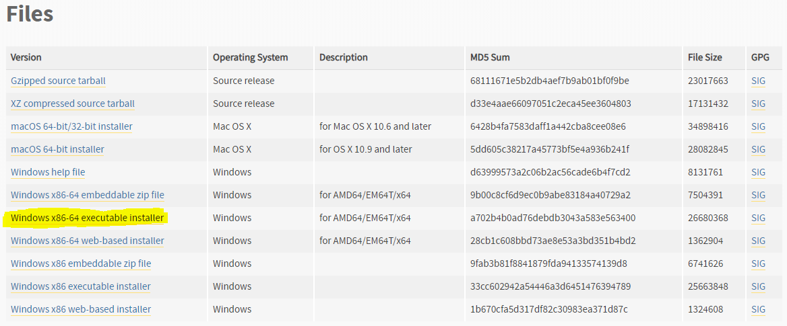

**Anaconda** [6]

To recognize the finger from a frame or image, it requires some mathematical function like the defect Counted at the convex Hull step the script has to eliminate the angle which is greater than 90 degree to accomplish this we have used Anaconda’s libraries.

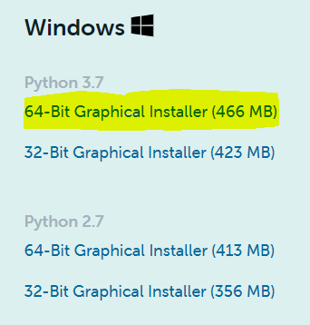

**Spyder [3]**

Spyder is a IDE Switch users Anaconda and Python and provide us environment easy to write the script for machine learning and we can run the script in the IDE only. This makes easy to run and write the scripts. any version of spider will work but it is recommended do use the latest version available.

Launching Spyder

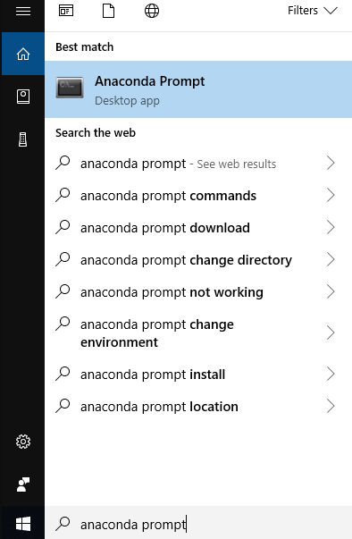

Hit the command “Spyder3”

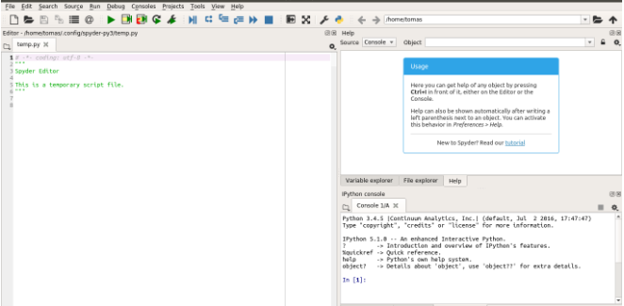

**OpenCV [4]**

OpenCV is the most important library in this project because the project depends on the camera. To capture the videos and to process the videos we will require a smart way to do that. Open CV makes easy to start grabbing the images from the camera just on button click or by writing few lines of code.

Installing openCV from pip :- pip3 install opencv-python

Haar cascade

Haar Cascade is XML file which is pre trained to recognizing the specific body part from any photo. In this project we required hand haar cascade. All the hard cascade XML file can we download from open CV repository.

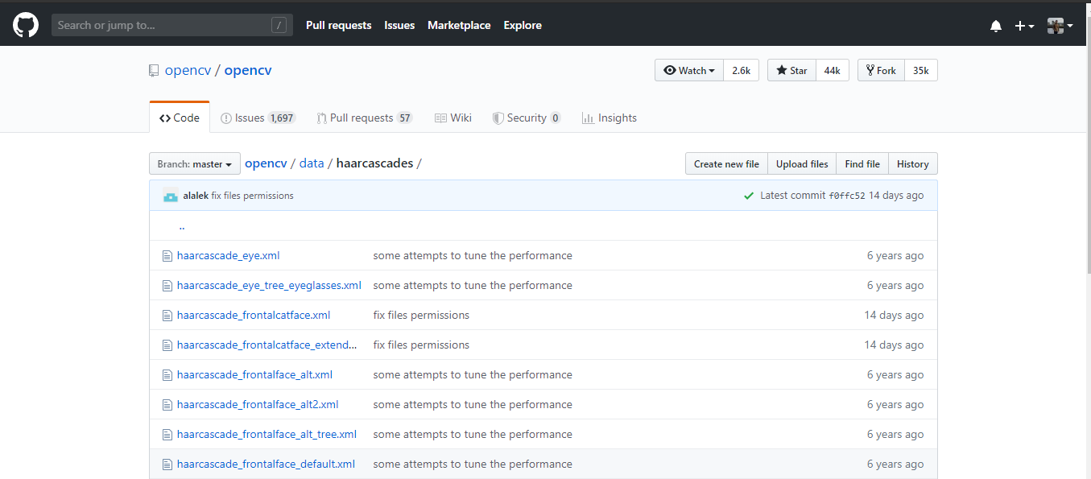

**Hand Haar Cascade**

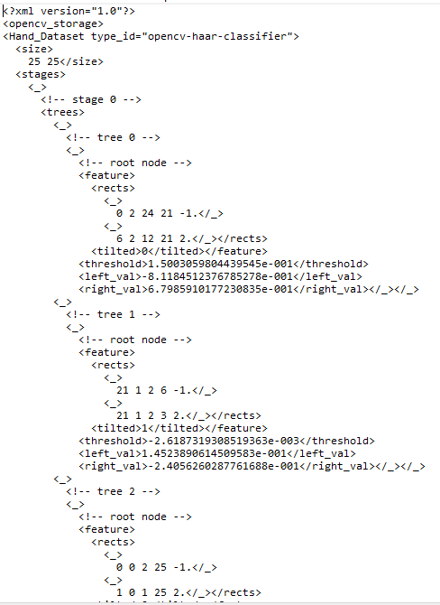

**Implementation of project**

**Step 1 : Hand Recognition** [8]

The most difficult part was to recognize the hand or in more specific term the number of fingers. By the help of open CV and hand haar cascade, the python script 1st extract hand from the video. Then by implementing Thresholding program will covert extracted hand in the binary form because machine can only understand the binary form.

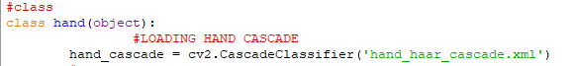

**Fig. Loading Haar cascase**

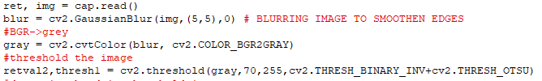

**Fig. Thresholding**

Now the image is converted in binary form, we will eliminate the background and will only get the hand by making a boundary of the hand using Contour. Now we will draw line to connect the outermost point of the hand which is going to be the fingers and that process is called as convex Hull. As all outermost part of hand is connected through line the script can create a triangle between two fingers, that means the angle between any two fingers is always going to be less than 90 degree. To get the angle I have used some libraries and mathematical functions that are provided by Anaconda [6]. The angle which is less than 90-degree script will count them as defect. and if the script gets angle greater than 90 degree it won't be considered as defect. The purpose of defect is to find the number of finger present in the frame. for an instance if the camera recognizes three finger then it will draw the line to connect the outermost part or the finger and will make two triangles which mean we have two angles less than 90 degrees as we know you have to angle less than 90 degrees the number of defect is 2 and plus one is going to be the number of fingers .

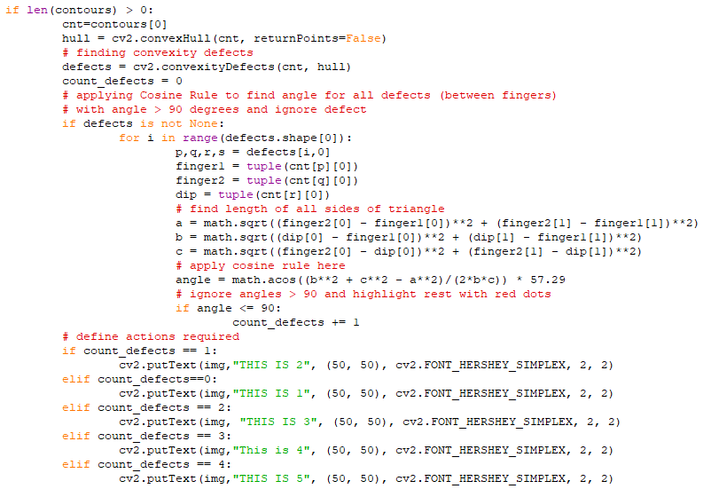

**After Step first program will be able to recognize the number of fingers correctly.**

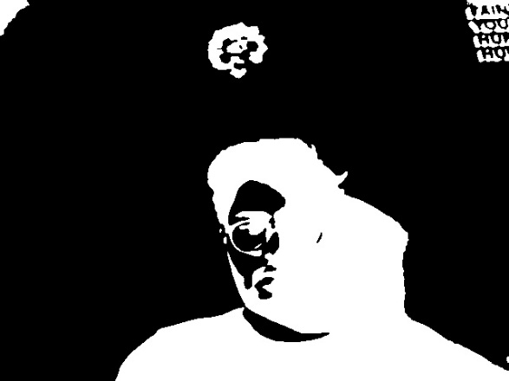

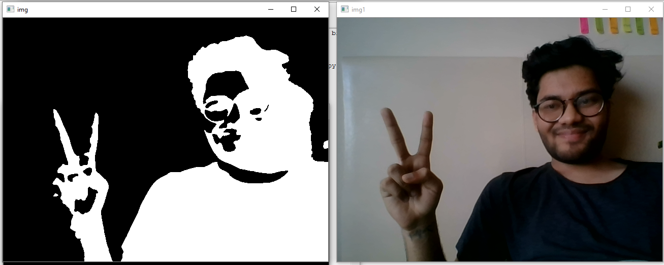

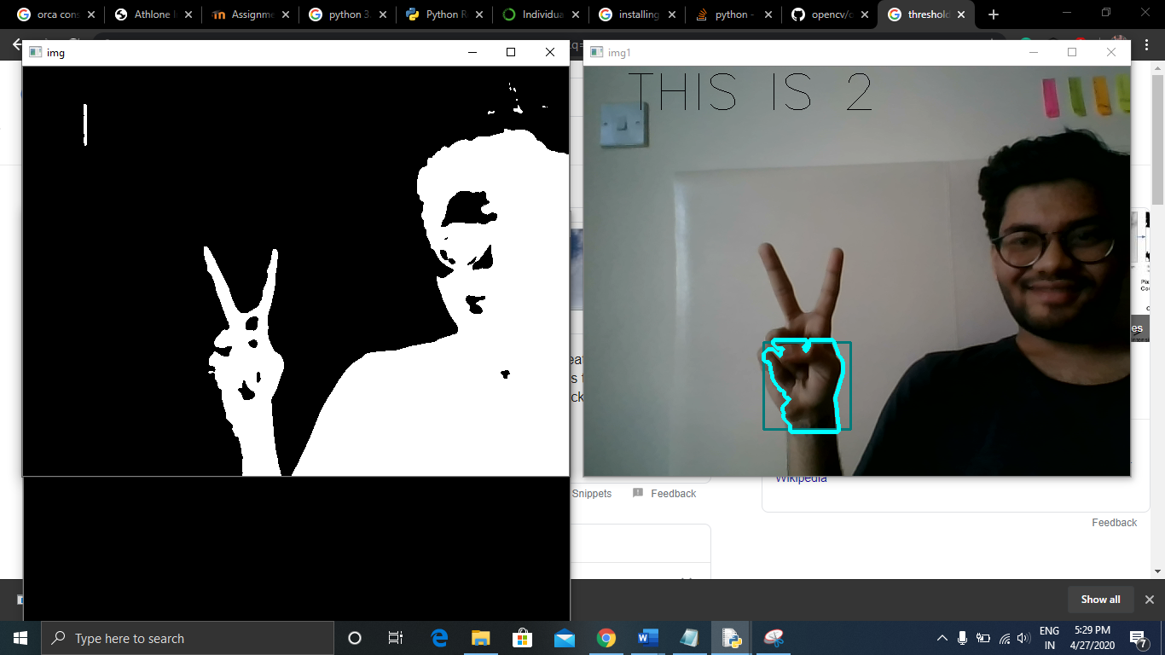

**Step 2:**

Changing of image automatically is done through threading because changing of image is being done independently it does not require anything from the mean script and the changing of image should not step stop at any moment of time unless user want to close the program.

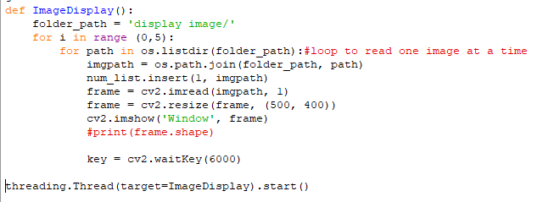

**Step 3**

At this stage the output of the hand recognition in a form of defect and image name at that point of time is taken after that if you want to update the score I have two synchronize the gesture I'm making and the image which is being displayed as soon as the player make the same gesture shown in the image then it will count the number of time the player made the same gesture as an image and then it will move to the next step.

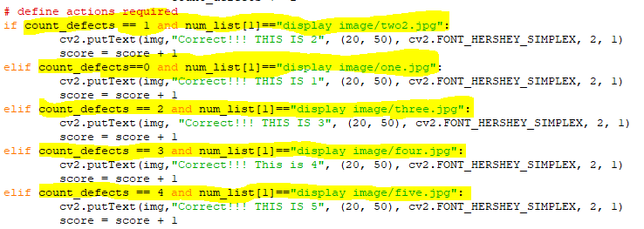

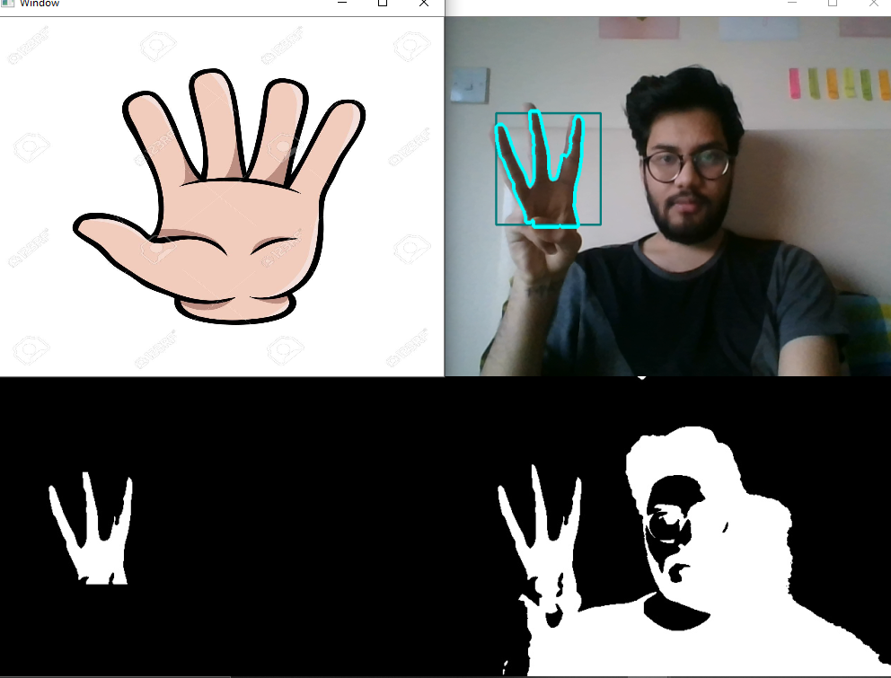



**Step 4**

If the output and image name synchronize the score will gets plus by one. Which can be seen in the console.

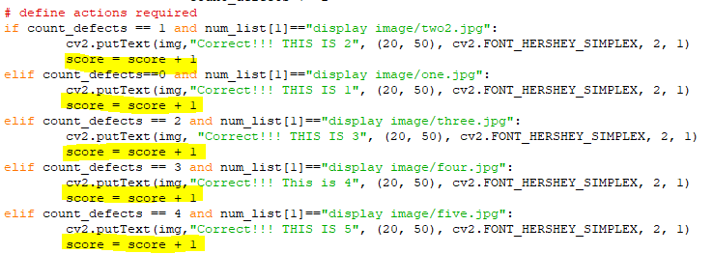

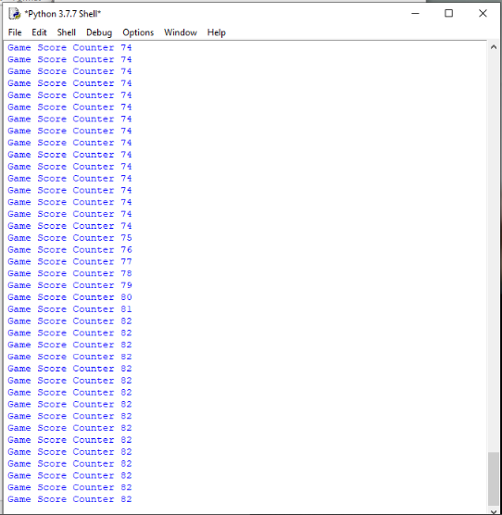

# Testing

In this project the testing is done in two parts

* 1st only recognizing hand (number of fingers)
* 2nd hand recognition with auto generated image

**Counting of fingers**

Test Case 1: To obtain correct number of fingers.

* At first it was not recognizing even my hand

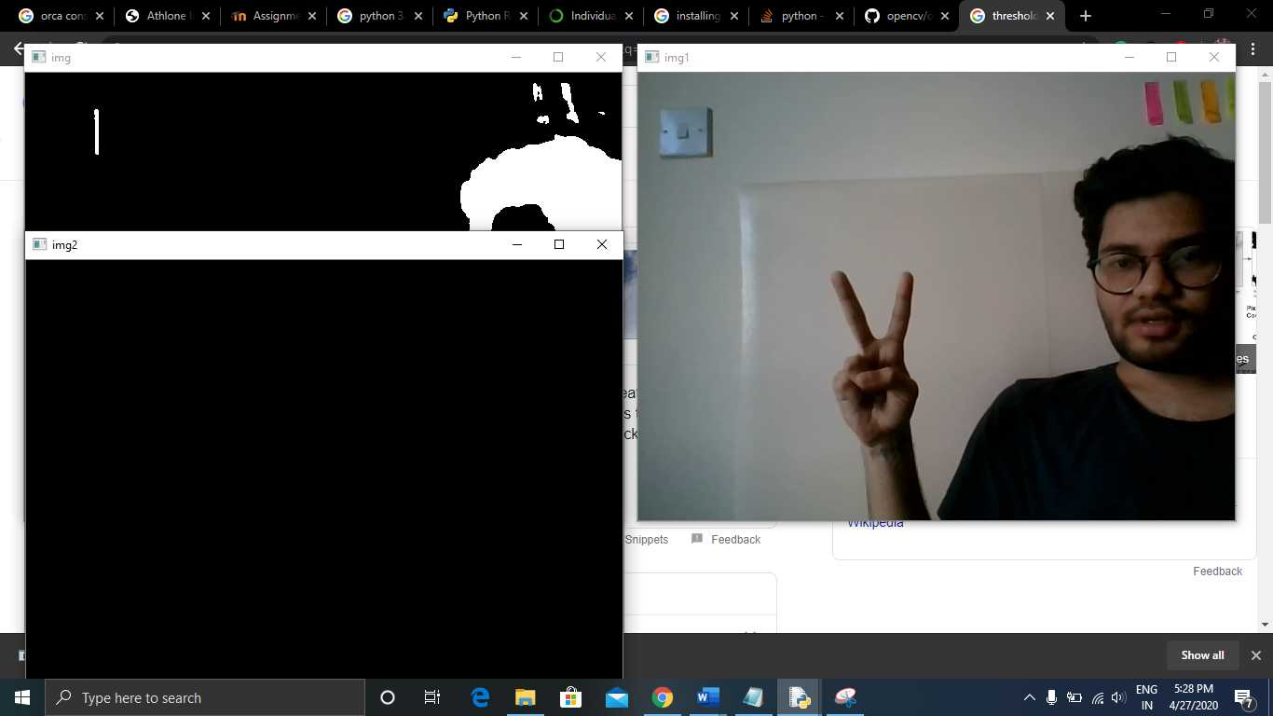

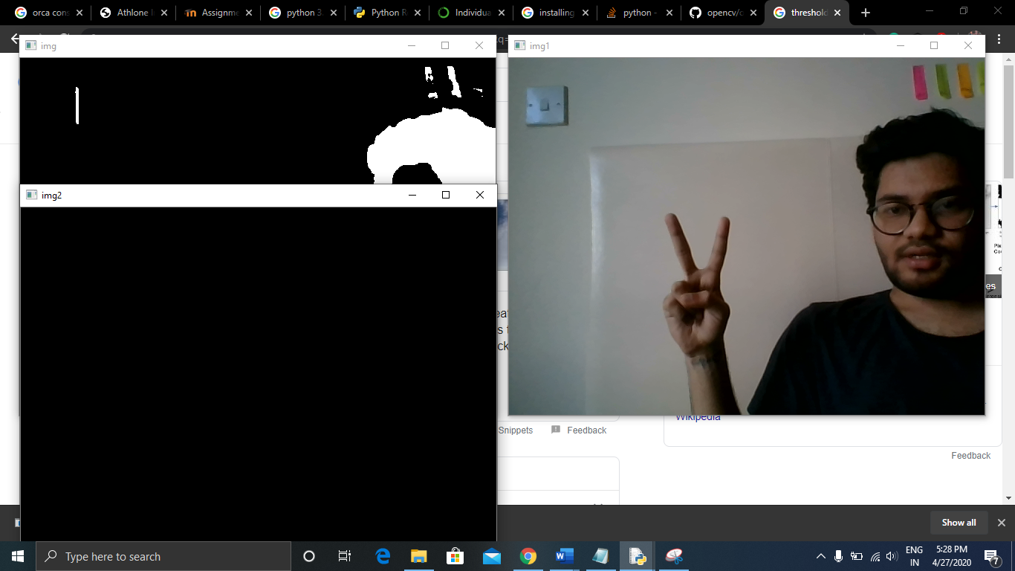

After few tries it start detecting my hand but the prediction was wrong

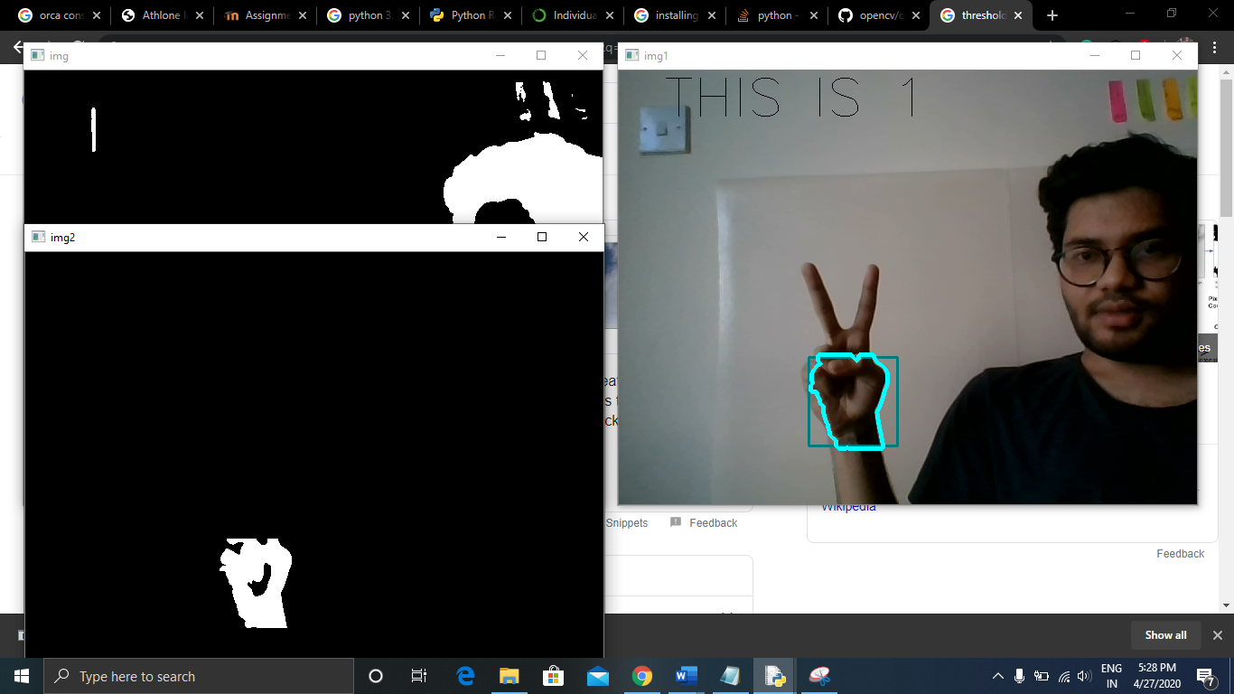

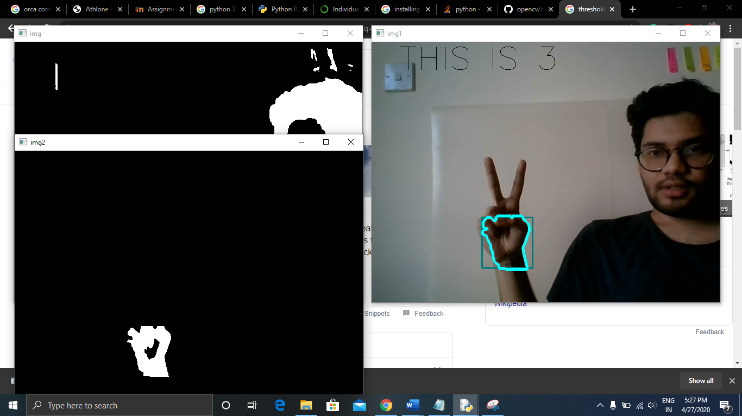

after couple of hours spending on the application started giving me the correct prediction

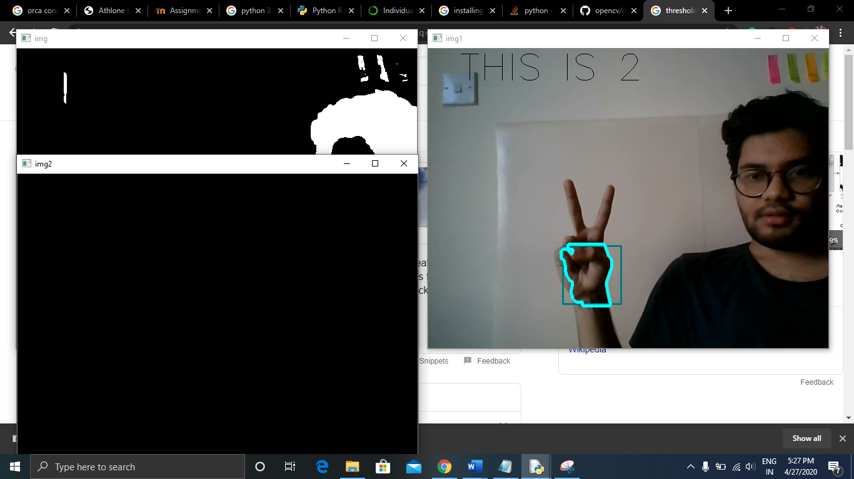

Counting fingers with auto image

Test Case 1: recognition at daytime with tilde camera

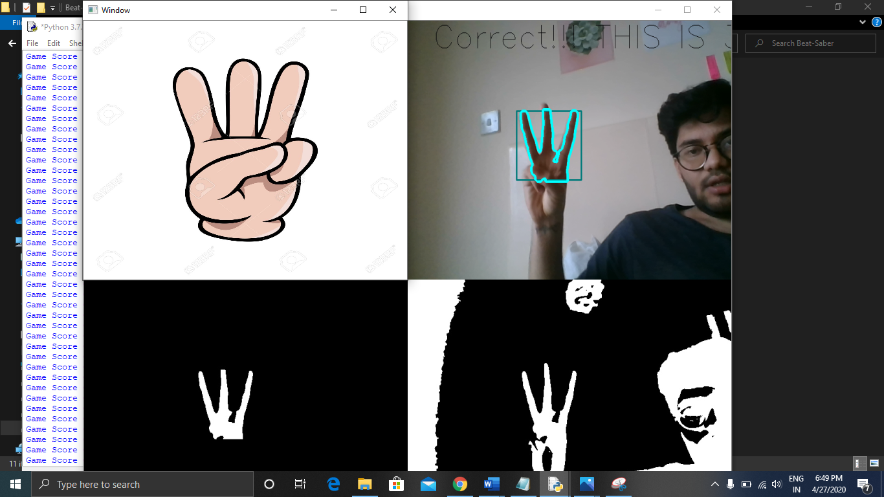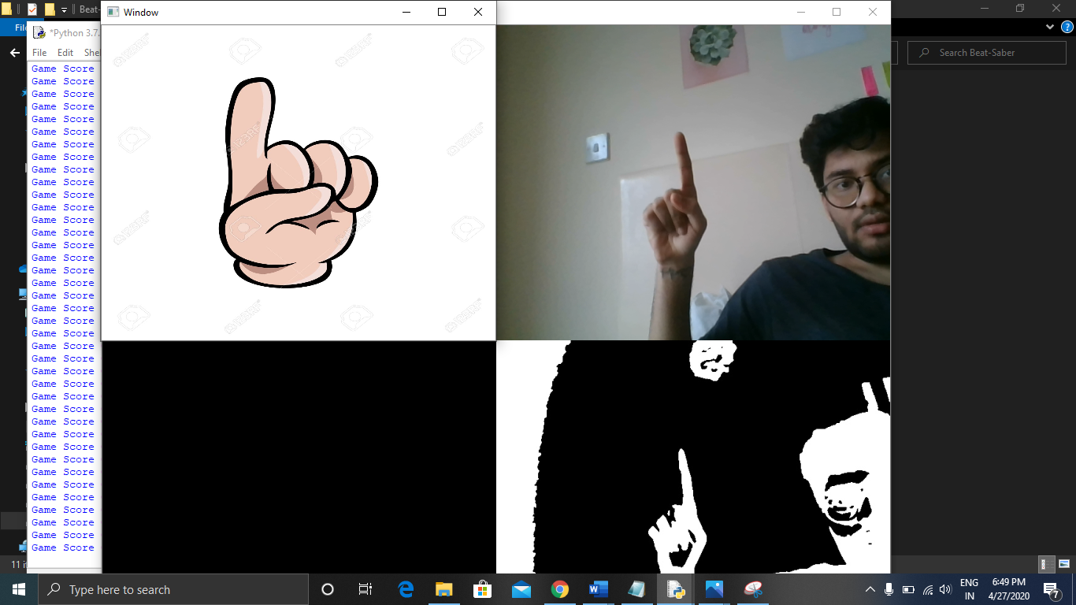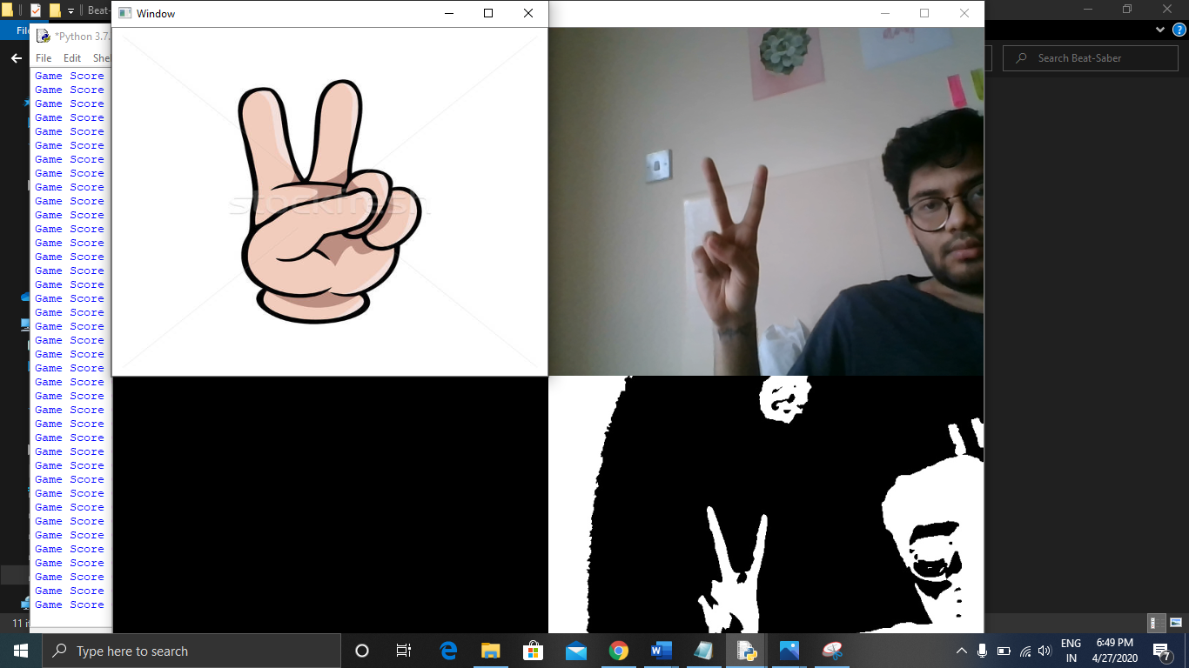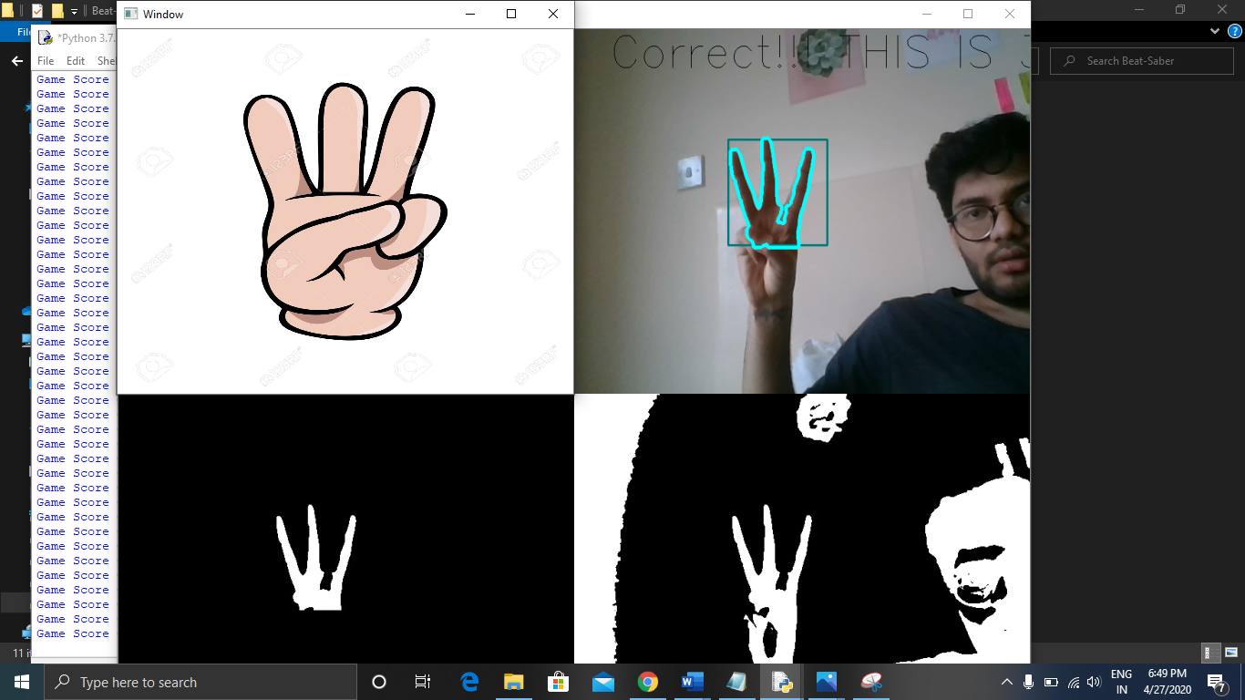

the project works fine with the tailed camera in daylight

test case 2: Counting fingers with a small palm 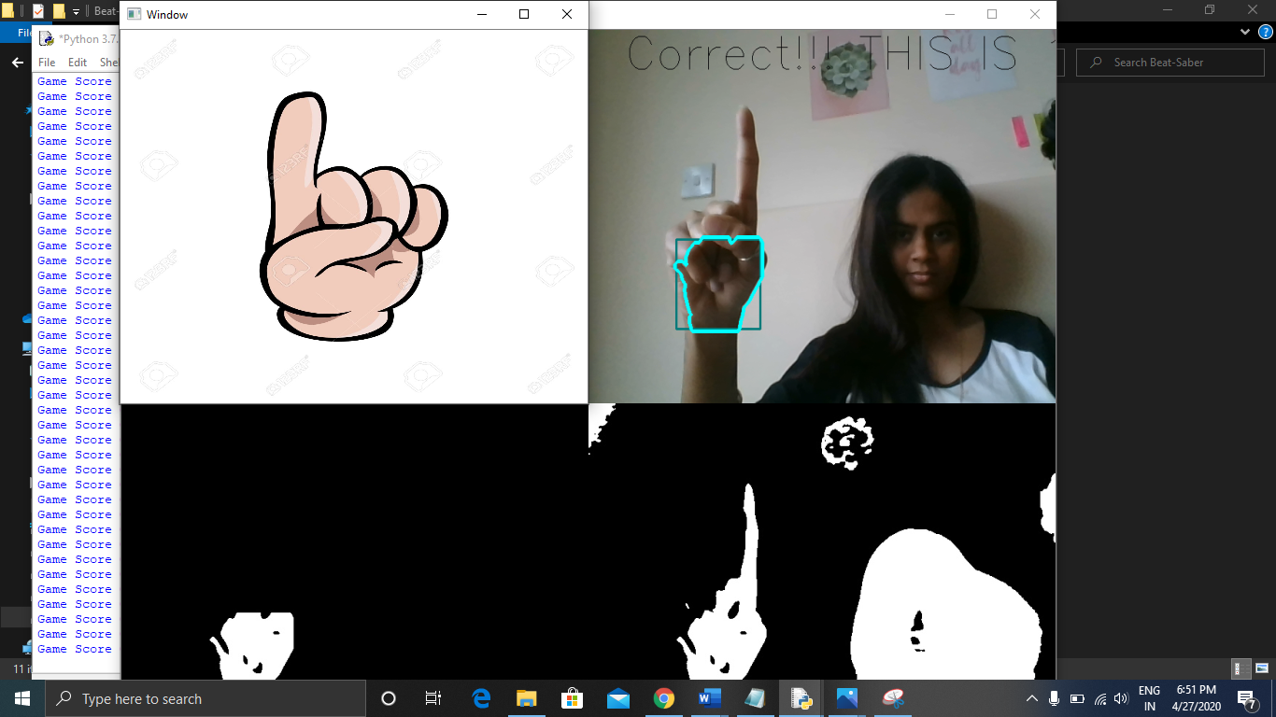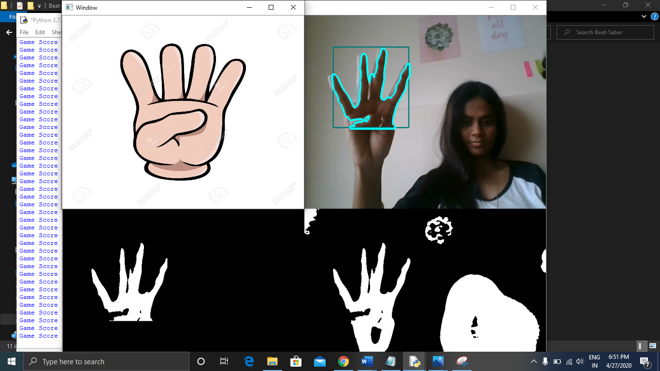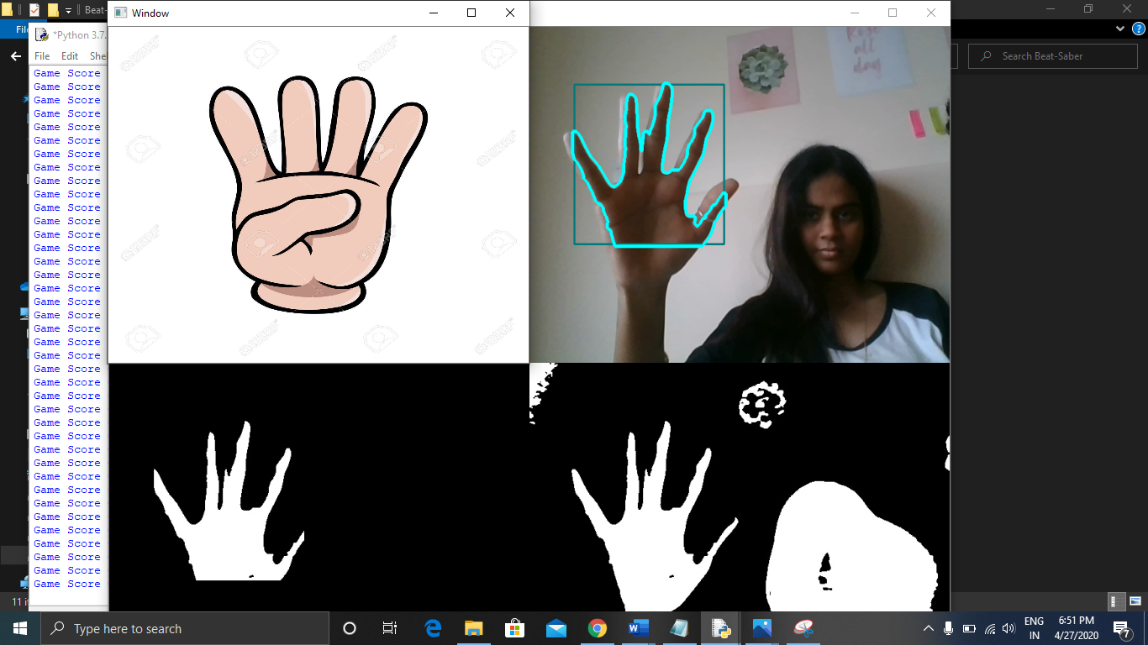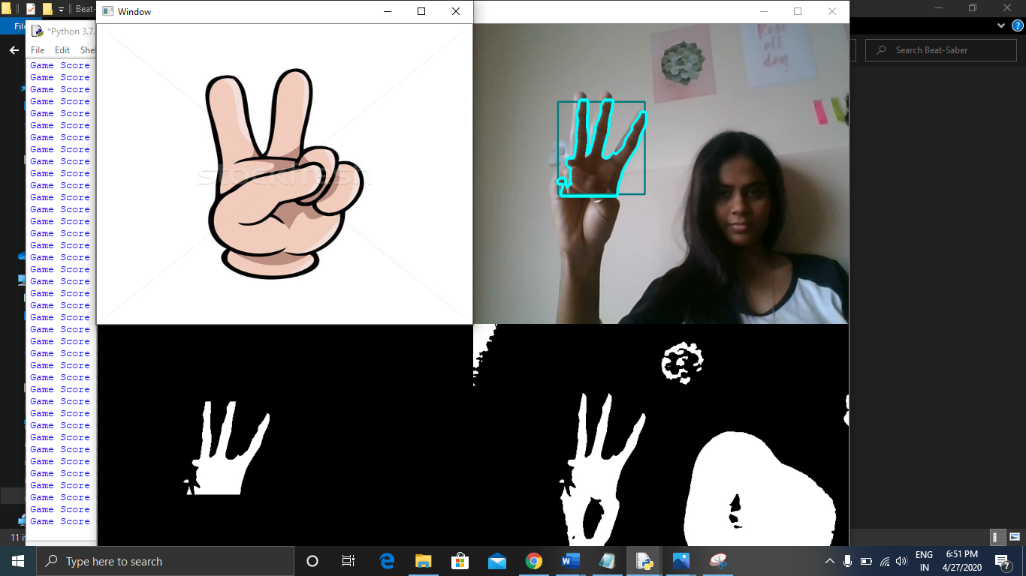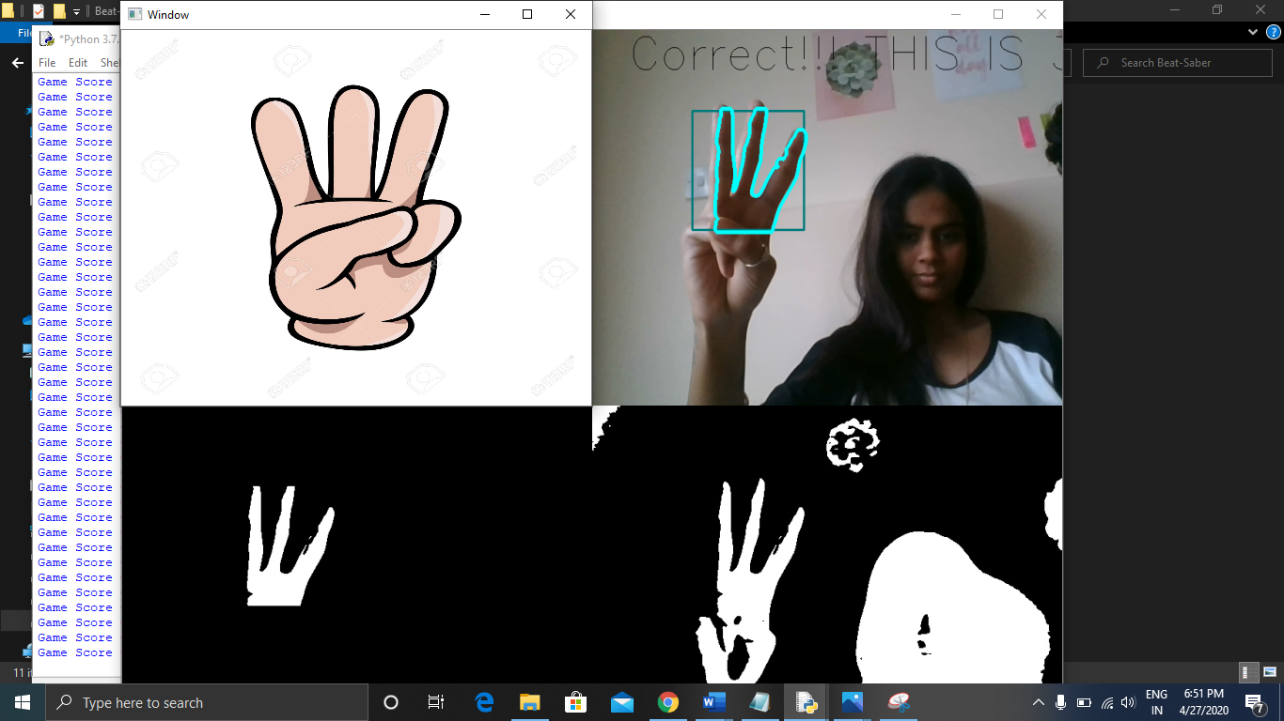

Results were quite satisfying, and it works well with small palm also.

Test case 3: count finger with lot of background

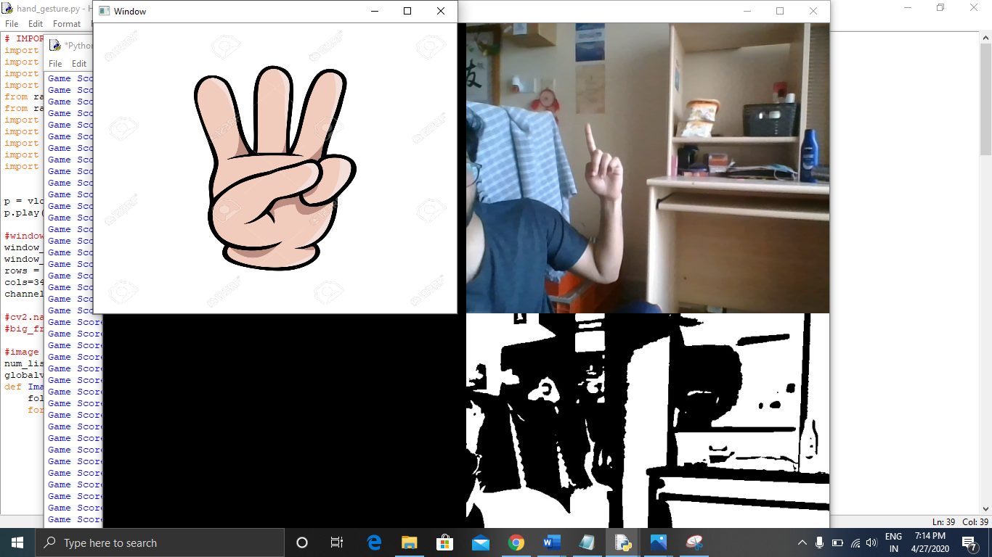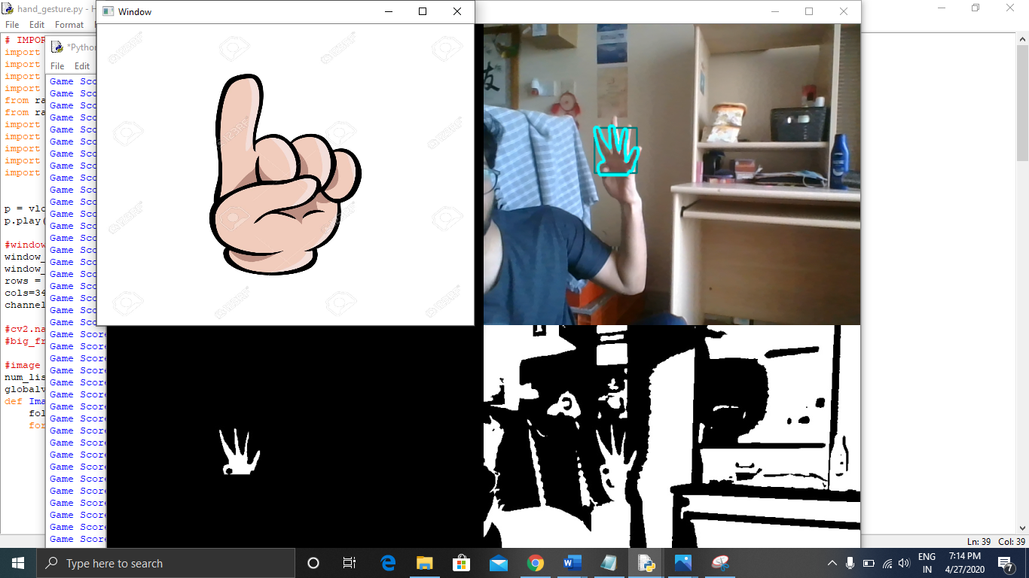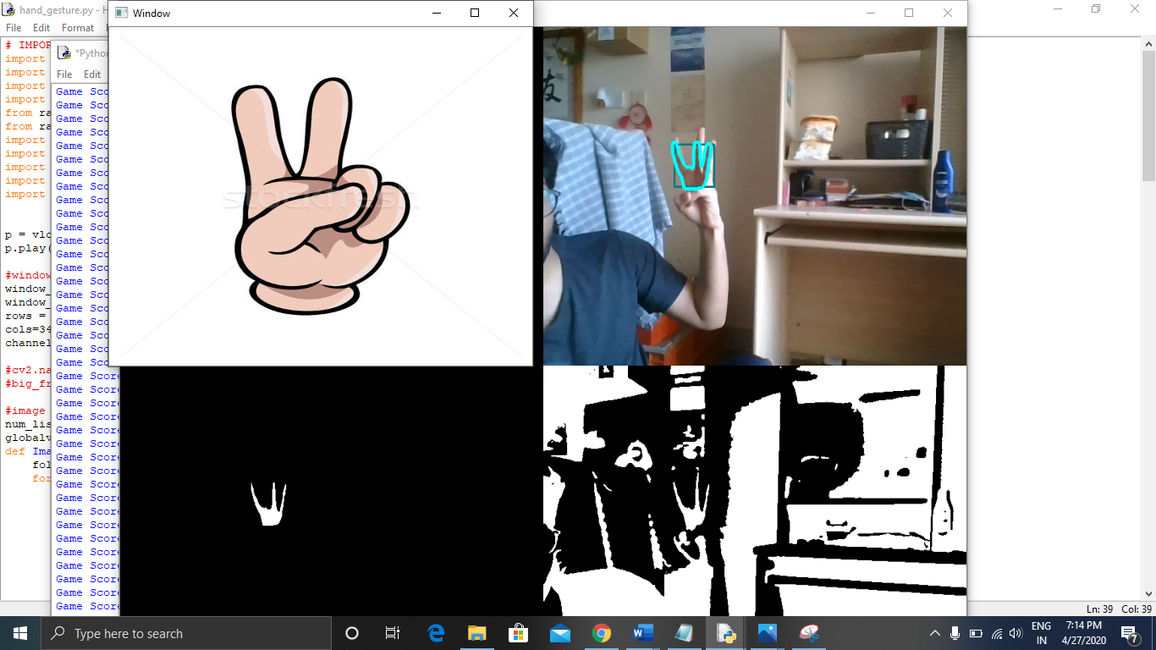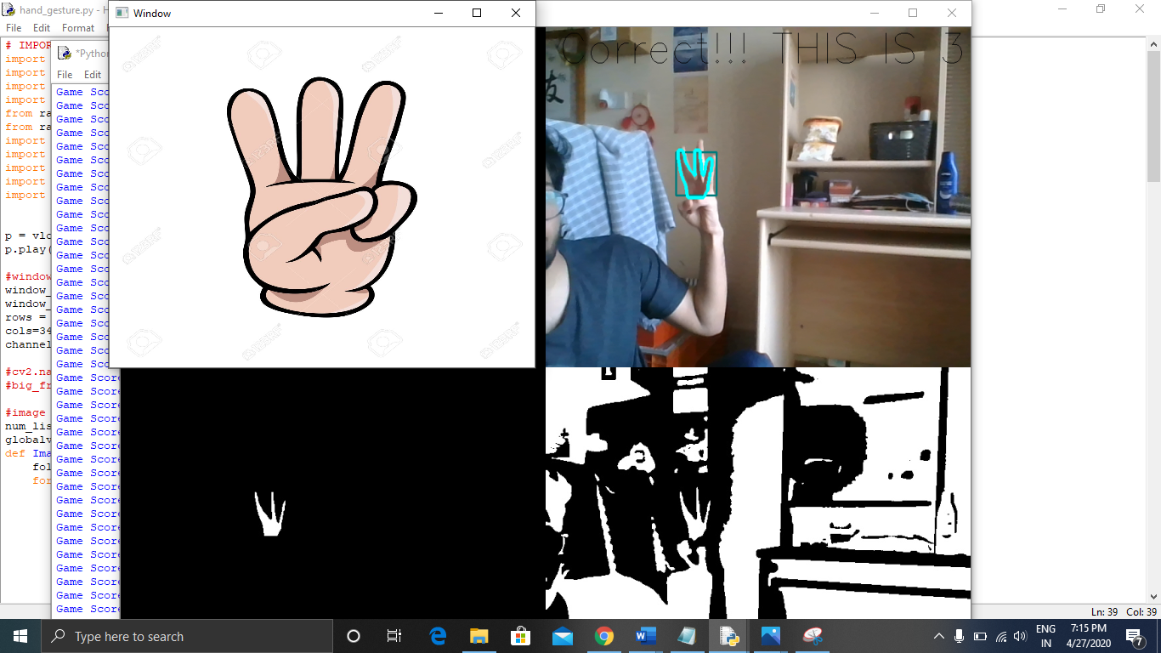

With alot of background it struggles to find the hand some times but still the accuracy is more than 40%

Test Case 4: count finger in bright light

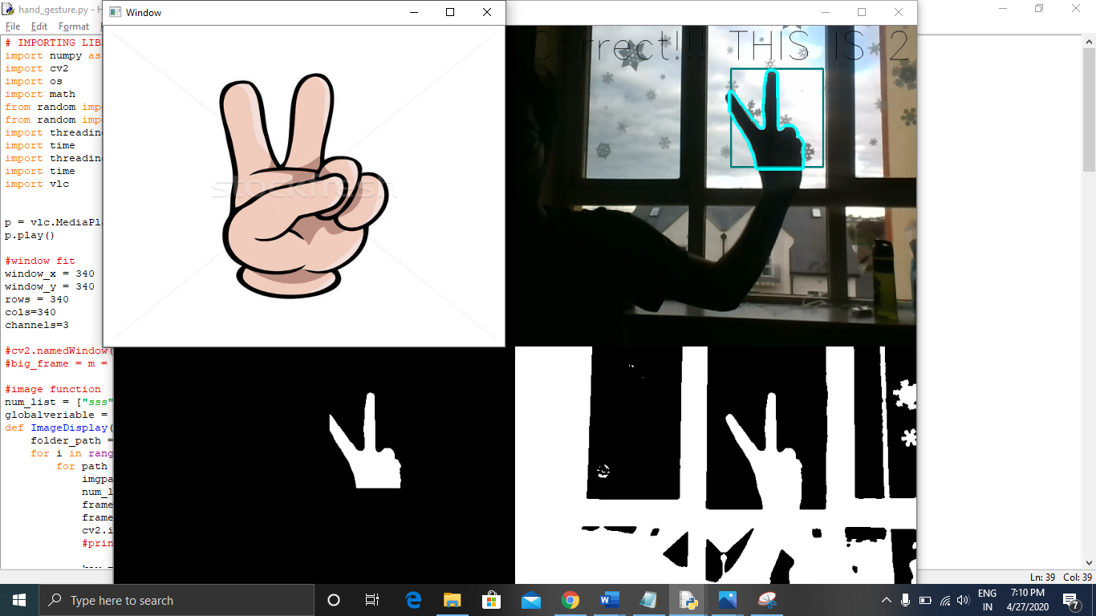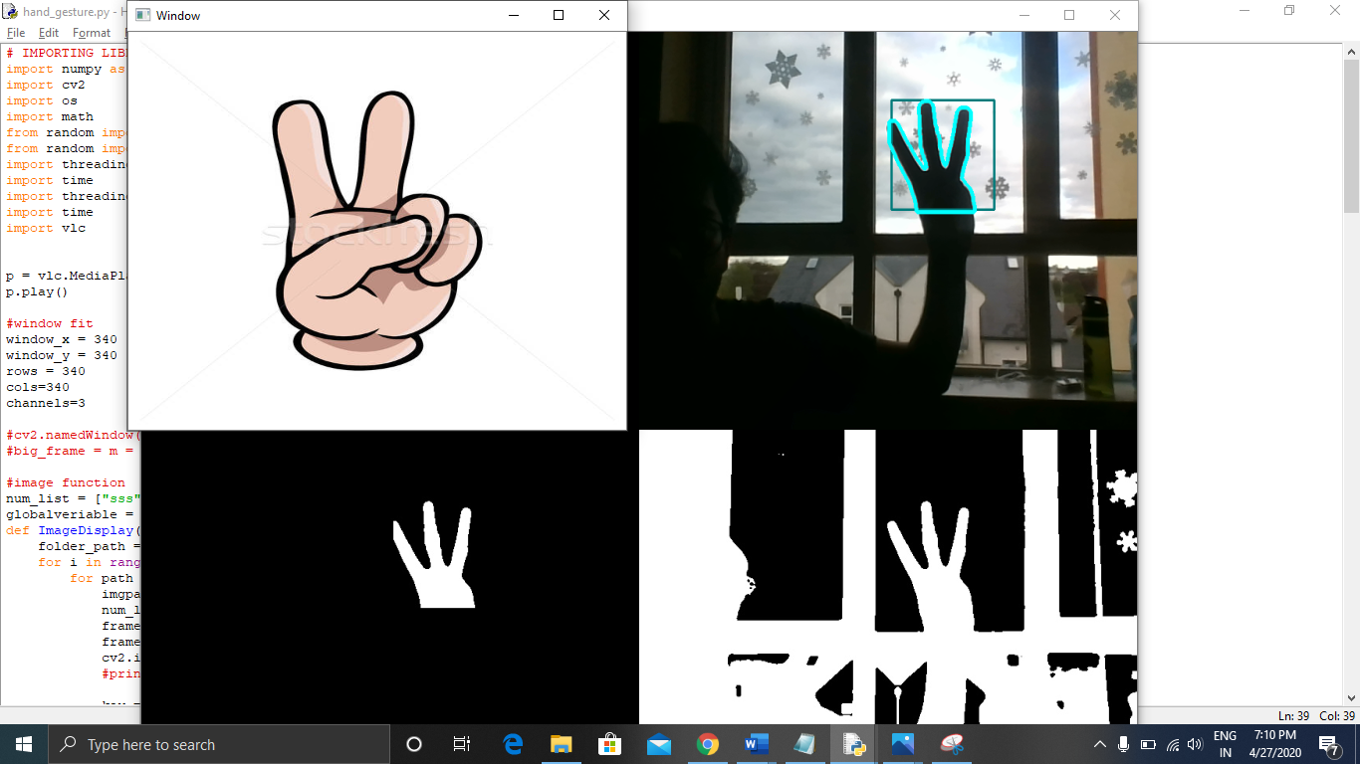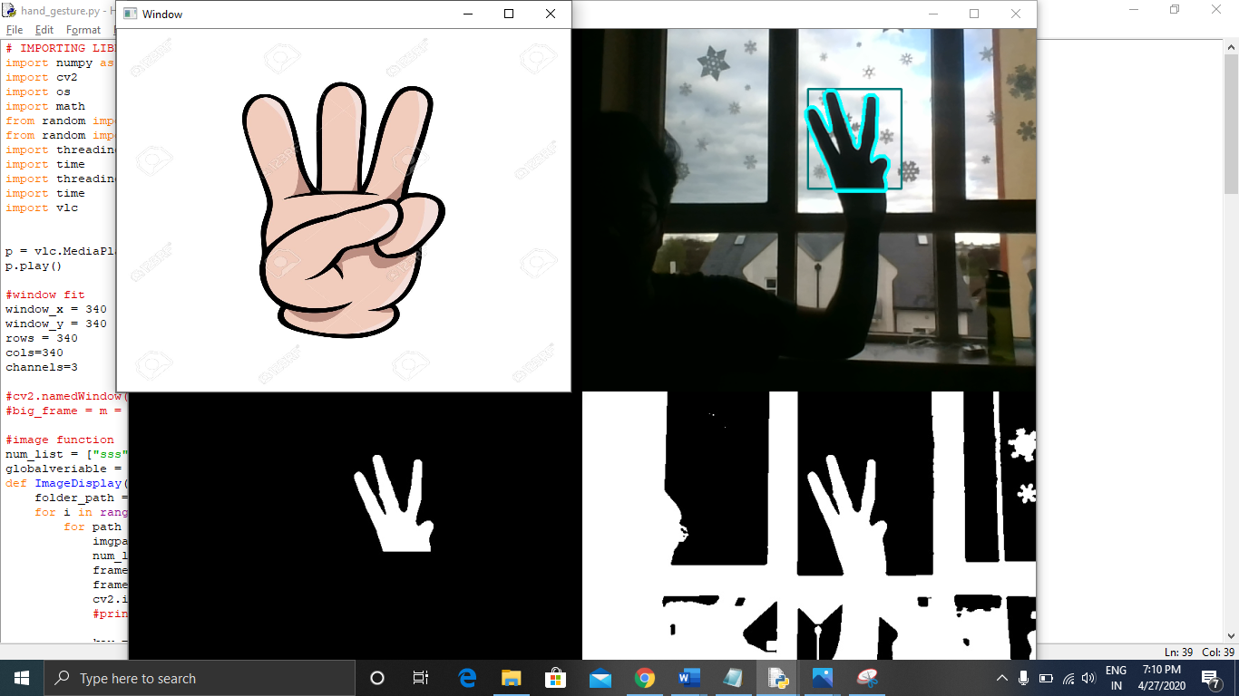

Accuracy was similar to the plain background.

# Evaluation

Beat Saber is completed successfully by keeping all the objective in mind. At beginning I started with the bigger scope to recognizing the whole body and the motion of have but it was to large to complete it in this short period of time. To recognizing the whole body, it might have taken external resource to complete the project and it might have changed the objective to the project which is to make the Beat Saber with minimum hardware requirement.

I have started with different approach to recognize the hand which was to train the model with lots of image by using TensorFlow and MobileNet but it does not focus on the number of finger rather it compares the test image with trained image which have not given me quite good result.

In order to complete the project then I have move to the method I have applied and in the end, results are great



# Conclusion

One of the key goals of the interactive virtual environments is to ensure normal, effective and versatile contact between user and machine [9]. Human gestures like finger, hand, and arms positions and movements reflect one of the finest non-verbal communication methods, which along with facial expressions and head movements enable human users to communicate with the virtual world in a natural way. Gestures may be static, where the person assumes a particular pose, or dynamic position, identified by motion.

Real-time vision-based hand gesture detection is among the most difficult areas of work in the field of human computer interaction [10]. Vision-based hand gesture recognition will depend on common video cameras already present to recognize hand gestures on a wide range of computers, tablets, mobile phones etc. In addition, the identification of non-contact visual movements is more normal, effective and useful than other dynamic human-computer systems such as data gloves, keyboards or mice.

This thesis introduced an original hand gesture recognition method, which deals with various transformations and cluttered context under various lightning conditions. As hand gesture recognition is mixed with many other technologies, such as voice recognition, the conventional mouse and keyboard can be eliminated for user interaction with the computer. The hand gesture recognition systems for creative applications can provide a very powerful and realistic interaction. Medical devices can also benefit greatly from the use of visual hand gesture contact during medical procedures in a sterile environment for an effective access to significant patient data.

# References

|  |  |
| --- | --- |
| [1] | B. GAMES, “Beat Saber Is a VR Workout for People Who Don't Like Exercise,” 2020. [Online]. Available: https://www.wired.com/story/vr-beat-saber-exercise/. |
| [2] | M. H. Tom Mitchell, “Machine Learning,” 1997. |
| [3] | R. Grehan, “Spyder review,” Sep 08, 2010. [Online]. |
| [4] | K. Pulli, A. Baksheev, K. Kornyakov and V. Eruhimov, “Realtime Computer Vision with OpenCV,” 1 April 2012. [Online]. |
| [5] | D. Kuhlman, “A Python Book: Beginning Python, Advanced Python, and Python Exercises,” 23 June 2012.. |
| [6] | I. Anaconda, “Getting started with Anaconda,” 2020. [Online]. |
| [7] | N. B. E. A. Matthias Rehm, “ Wave Like an Egyptian – Accelerometer Based Gesture Recognition for Culture Specific Interactions,” 2007. |
| [8] | P. V. a. M. Jones, “Rapid Object Detection using a Boosted Cascade of Simple Features,” 2001. |
| [9] | Python, “Creation of virtual environments,” 2019. [Online]. Available: https://docs.python.org/3/library/venv.html. |
| [10] | D. H. Ballard and C. M. Brown, “Computer Vision,” 1982. |